**SMART STAR EXAMINATIONS BOARD**

**END OF TERM I EXAMINATIONS - 2024**



READING

**PRIMARY ONE**

***Time Allowed: 2*** *hours* ***15*** *minutes*

**Name...........................................................Stream............**

**INSTRUCTIONS**

1. ***Avoid unnecessary crossing of work.***
2. ***Use very good handwriting.***
3. **Fill in the missing sounds.**

|  |  |  |  |
| --- | --- | --- | --- |
|  |  |  |  |
| **ba__ket** | **b__g** | **__en** | **swi__g** |

1. **Join and form words.**

de – sk = ____________

pla – nt = ___________

fa – n = ____________

1. **Circle the correct words for the picture.**

grass glass

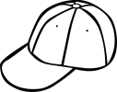 cap cup

tin teen



boll ball

1. **Tick the vowel sounds.**

s a t p i n

o r e u g m

1. **Underline the odd man out.**

bag, bar, band, big

clap, class, slap, clan

men, mill, mix, milk

1. **Make sentences.**

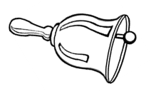

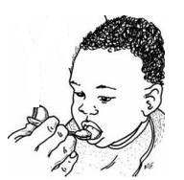 **____________________________________**

**Ring the correct word for the given sound.**

ch: sheep, chair, stick

oo: boat, cook, eat

ee: sweep, teach, kick

1. **Write the last sound for the word.**

drum _____________

pot _______________

box _______________

flag _______________

**9. Fill in the missing sounds.**



**t__ __cher** **st__ ck**

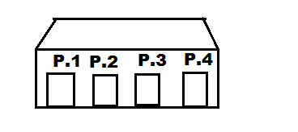

**cla__sr__ __ms 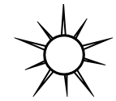s__n**

1. **Answer correctly.**
2. What is your name?

______________________________

1. In which class are you?

_______________________________

1. **Form words.**

sta _______________

ba r _______________

fa _______________

ca _______________

1. 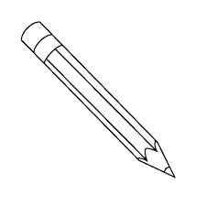**Write the first syllable for the picture.**

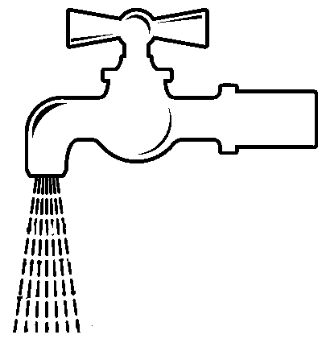

1. **Read and draw.**
2. The flower is in the pot.
3. I can see five eggs.
4. **Read the story and answer questions.**

Jane is six years old. She is in Primary one at Kamu Primary School. Jane lives with her mother and her brother. She likes her mother so much.

**Questions:**

1. What is the name of the girl in the

story?

__________________________________

1. The name of the girl in the story is

__________________________________

1. How old is she?

___________________________________

1. Jane goes to _____________Primary School.
2. Write one word of sound “oo” in the story.____________________________
3. Draw Jane and her mother.

**END.**